**Machine Learning Model Development With IBM Cloud Watson Studio**

**Submitted by : P. charitha**

**Reg.no : 723921104036**

**E-mail I’d :charithareddy713@gmail.com**

**INNOVATION :**

Machine learning model development with IBM typically refers to the process of creating, training, and deploying machine learning models using IBM's suite of tools and platforms, particularly those within the IBM Cloud ecosystem. IBM offers several services and products that facilitate various stages of the machine learning model development process.

**What is meant by machine learning model development with IBM ?**

1. **Data Preparation:** IBM provides data integration and data preparation tools that allow you to collect, clean, and transform data into a format suitable for machine learning. This includes services like IBM DataStage and IBM Data Refinery.
2. **Model Building and Training:** IBM offers machine learning platforms that enable you to develop and train machine learning models. IBM Watson Studio is a notable tool for model development. It provides integrated Jupiter notebooks, collaboration features, and access to a wide range of machine learning libraries, including scikit-learn, TensorFlow, and Torch.
3. **Automated Machine Learning (Auto ML):** IBM offers Auto AI, an automated machine learning service within Watson Studio. It automates much of the model development process, making it accessible to users with varying levels of data science expertise.
4. **Model Deployment:** IBM Cloud Pak for Data and Watson Machine Learning enable you to deploy machine learning models as REST APIs, web services, or batch processes. These services provide scalability and reliability for serving models in real-time applications.
5. **Model Monitoring and Management:** IBM provides tools for monitoring the performance of deployed models and managing model versions. This ensures that models continue to perform effectively in production.
6. **Explain ability and Fairness:** IBM's AI Fairness 360 toolkit and Watson Open Scale help ensure that machine learning models are fair and transparent, addressing concerns related to bias and ethical AI.
7. **Integration with Other Services:** IBM services can be integrated with various other IBM Cloud offerings, such as IBM Cloud Databases, storage solutions, and analytics services, to create end-to-end machine learning solutions.
8. **Enterprise-Level Security and Compliance:** IBM offers robust security and compliance features, making it suitable for businesses and organizations with strict data protection requirements.
9. **Collaboration and Sharing:** IBM Watson Studio facilitates collaboration among data scientists, data engineers, and domain experts, making it easier to work on machine learning projects as a team.
10. **Community and Support:** IBM provides a community of data scientists, access to tutorials, and technical support to assist users in their machine learning model development .

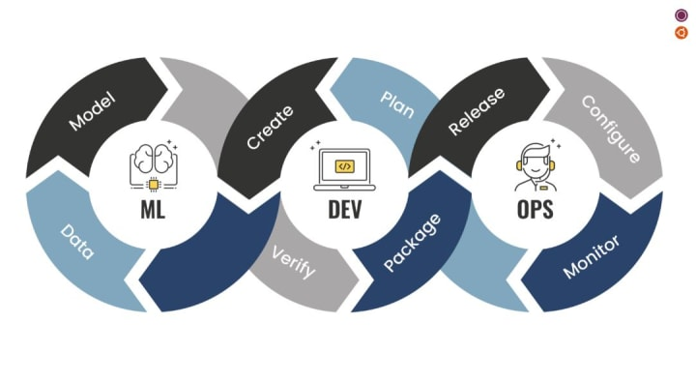

**What are the types of languages used in machine learning ?**

1. **Python:** Python is the most popular language for machine learning and artificial intelligence. It offers a wide range of libraries and frameworks like TensorFlow, eras, Torch, scikit-learn, and more, making it the language of choice for many data scientists and machine learning engineers.
2. **R:** R is another language often used in machine learning, particularly for statistical analysis and data visualization. It has a strong ecosystem of packages for machine learning, such as caret, random Forest, and boost.
3. **Java:** Java is widely used in the development of machine learning applications, especially for large-scale projects. Libraries like Weka, Deeplearning4j, and MOA are popular in the Java ecosystem.
4. **C++:** C++ is chosen for its performance and efficiency, particularly in building machine learning libraries and applications. Libraries like TensorFlow and OpenCV have C++ APIs.
5. **Julia:** Julia is a relatively new language gaining popularity in the machine learning community due to its speed and ease of use. It has machine learning libraries like Flux and MLJ.
6. **MATLAB:** MATLAB is widely used in academic and research settings for machine learning and data analysis. It has many built-in functions for numerical computing and machine learning.
7. **SAS:** SAS is a specialized software suite used in statistical analysis, data mining, and machine learning for enterprise applications.
8. **Scala:** Scala is known for its compatibility with Java and is used in machine learning libraries like Apache Spark, which is widely used for big data processing and analytics.

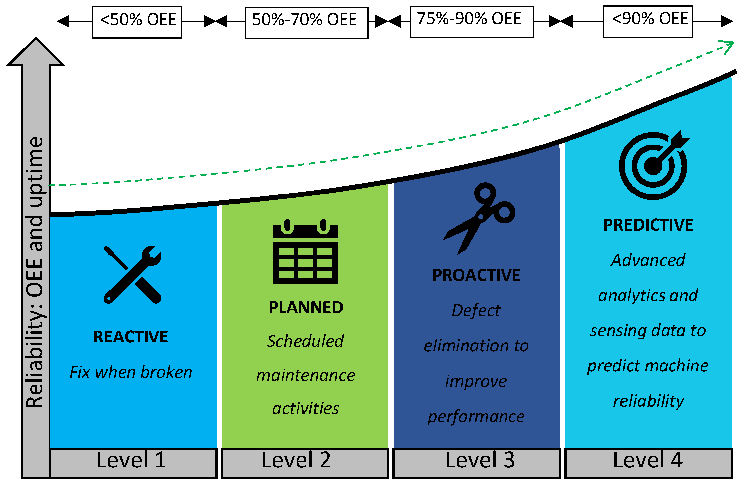

**Why machine learning is important ?**

Machine learning is important for a variety of reasons and has a profound impact on various fields. Here are some key reasons why machine learning is considered important:

1. **Data-Driven Decision-Making:** Machine learning allows organizations and individuals to make data-driven decisions. By analyzing vast datasets, machine learning models can uncover patterns, insights, and trends that would be challenging or impossible to identify with traditional methods.
2. **Automation:** Machine learning enables automation of tasks that were previously performed manually. This not only saves time but also reduces human error and allows people to focus on more complex and creative aspects of their work.
3. **Personalization:** Machine learning powers recommendation systems used in e-commerce, content streaming, and advertising. These systems personalize content and product recommendations based on individual preferences, improving user experiences.
4. **Predictive Analytics:** Machine learning models can predict future outcomes based on historical data. This is valuable in various domains, including finance, healthcare, weather forecasting, and supply chain management.
5. **Image and Speech Recognition:** Machine learning has revolutionized image and speech recognition, enabling applications like facial recognition, voice assistants, and self-driving cars.

**Conclusion :**

In conclusion, machine learning is a transformative technology with a profound impact on various fields, making it a critical component of the modern digital landscape. Its importance is underscored by its ability to analyze vast amounts of data, automate tasks, personalize experiences, and make predictions, among other capabilities.